C4-S2-PRACTICE

What you need to know :
INNER JOIN table_name ON, EXISTS and NOT EXISTS
Exercise 1 online editor
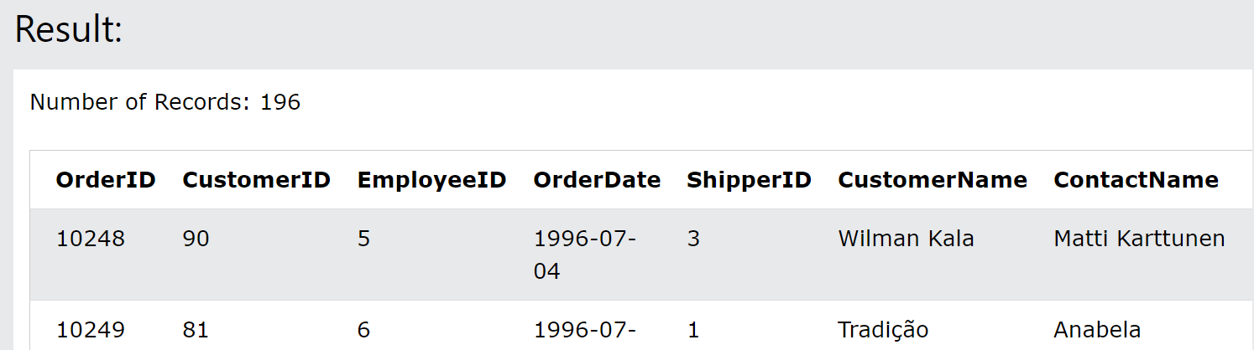
Q1: Choose the correct JOIN clause to select all records from the two tables where there is a match in both tables.

Answer :
SELECT * FROM Orders INNER JOIN Customers ON Orders.CustomerID=Customers.CustomerID;
Q2: Choose the correct JOIN clause to select all the records from the Customers table plus all the matches in the Orders table.
SELECT distinct suppliers.country as "Suppliers-Country", customers.customername from customers, suppliers where suppliers.country = customers.country;
Exercise 2 working with phpMyAdmin
Use phpMyAdmin and this database: doctors_appointment_db.sql
Exercise #1
Need the name and time of the patients in the appointment_list.
Result:
name | schedule
Patrick Roethlisberger | 2020-09-30 11:00:00
Patrick Roethlisberger | 2020-09-28 10:00:00
Patrick Roethlisberger | 2020-10-12 13:00:00

QUERRY:
SELECT name, schedule FROM `appointment_list` INNER JOIN patient_list ON patient_id = patient_list.id

Exercise #2
Find the name of the users that are not doctors.
QUERRY:
SELECT `name` FROM `users` WHERE NOT EXISTS (SELECT id FROM doctors_list WHERE doctor_id = id)
RESULT:
name
Administrator
George Wilson

Exercise #3
Which doctor has no appointement
QUERRY:
SELECT name FROM `doctors_list` WHERE NOT EXISTS (SELECT doctor_id FROM appointment_list WHERE doctors_list.id = doctor_id)
Result: 3
Claire Blake

Exercise #4
Need to see the schedule list with name of the doctors, not their id’s
QUERY:
SELECT name, day, time_from, time_to FROM `doctors_schedule` INNER JOIN doctors_list ON doctor_id = doctors_list.id
Result:
name |  | day |  | time_from | time_to
James Smith |  | Monday |  | 10:00:00 | 17:00:00
James Smith |  | Wednesday |  | 10:00:00 | 17:00:00
Claire Blake |  | Monday |  | 10:00:00 | 15:00:00
Claire Blake |  | Tuesday |  | 10:00:00 | 15:00:00
Claire Blake |  | Wednesday |  | 10:00:00 | 15:00:00
Claire Blake |  | Thursday |  | 10:00:00 | 15:00:00
Claire Blake |  | Friday |  | 10:00:00 | 15:00:00
This is why I hate ms-word

Exercise #5
Now, make a VIEW of that query and call it schedule_w_doc_name.
(You may need to empty session data to see your view, but it is there)
Now using that new VIEW, show us who works on Wednesday.
QUERY:
SELECT name FROM `schedule_w_doc_name` WHERE day = 'Wednesday'
Result:
name
James Smith
Claire Blake

